INSERT:

**SQL Query - 1**

**Send Feedback**

**Problem statement :**  
Formulate a query to add records to table **tutorials.**  
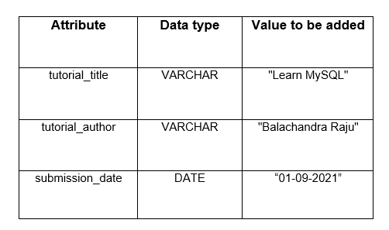

Note: Print the table after adding the values.

+----------------+------------------+-----------------+

| tutorial_title | tutorial_author | submission_date |

+----------------+------------------+-----------------+

| Learn MySQL | Balachandra Raju | 01-09-2021 |

+----------------+------------------+-----------------+

INSERT INTO tutorials (tutorial_title, tutorial_author, submission_date)

values ('Learn MySQL','Balachandra Raju','01-09-2021');

select * from tutorials;

**SQL Query - 3**

**Send Feedback**

**Problem Statement**  
Formulate queries to insert multiple rows into the table **BankAccount:** with the following values:  
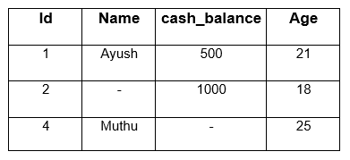

**Information about the table:**  
Attribute List for table **BankAccount:**  
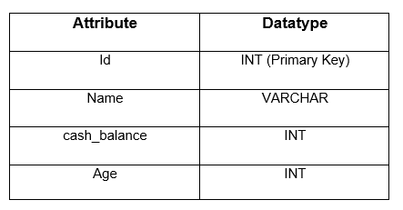

Note: Print the complete table after adding the values.

+----+-------+--------------+------+

| Id | Name | cash_balance | Age |

+----+-------+--------------+------+

| 1 | Ayush | 500 | 21 |

| 2 | NULL | 1000 | 18 |

| 4 | Muthu | NULL | 25 |

+----+-------+--------------+------+

INSERT INTO BankAccount (Id,Name,cash_balance,Age)

values (1,'Ayush',500,21),

(2,NULL,1000,18),

(4,'Muthu',NULL,25);

Select * from BankAccount;

**UPDATE:**

**SQL Query - 4**

**Send Feedback**

**Problem Statement**  
Write Queries to:  
1. Update the Age of Id 2 to 18.  
2. Update the cash_balance of Muthu to 2000.

Note: These two are seperate queries.

**Information about the table**

Table **BankAccount:**



Note: Print the complete table BankAccount after these updation.

+----+--------+--------------+------+

| Id | Name | cash_balance | Age |

+----+--------+--------------+------+

| 1 | Ayush | 500 | 21 |

| 2 | Aniket | 1000 | 18 |

| 4 | Muthu | 2000 | 25 |

+----+--------+--------------+------+

Update BankAccount set Age = 18 where Id = 2;

Update BankAccount set cash_balance = 2000 where Name = 'Muthu';

select * from BankAccount;

**SQL Query - 5**

**Send Feedback**

**Problem Statement:**  
Given a table named **stud_data**, formulate a query to change the **Fname and Age** of the already entered record to **( Neelabh, 22 )** of **roll number 17**.  
  
**Information about the table**  
Table **stud_data :**  
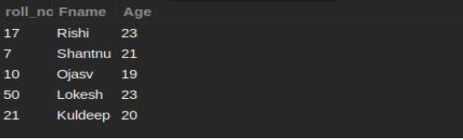

Note: Print the complete table after updating the data.

UPDATE 1

roll_no | fname | age

---------+----------------------------------------------------------------------------------------------------------------------------------------------------------------------------------------------------------+-----

7 | Shantnu | 21

10 | Ojasv | 19

50 | Lokesh | 23

21 | Kuldeep | 20

17 | Neelabh | 22

(5 rows)

Update stud_data set Fname = 'Neelabh',

Age = 22 where roll_no = 17;

Select * from stud_data;

**SQL Query - 6 ( Part -1 )**

**Send Feedback**

**Problem Statement**  
Formulate a query to update the table accordingly and show the updated table.  
  
As the company is celebrating its 5th anniversary, the company is updating the salaries of all people with positions “SDE” and “CA” to 150000.  
  
**Information about the table**  
Table **Employee:** 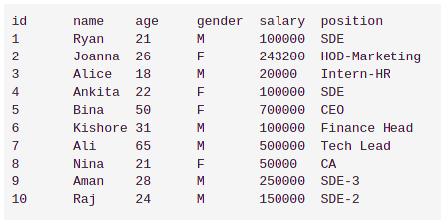

Note: Print the complete table after updating the data.

+----+---------+-----+--------+--------+---------------+

| id | name | age | gender | salary | position |

+----+---------+-----+--------+--------+---------------+

| 1 | Ryan | 21 | M | 150000 | SDE |

| 2 | Joanna | 26 | F | 243200 | HOD-Marketing |

| 3 | Alice | 18 | M | 20000 | Intern-HR |

| 4 | Ankita | 22 | F | 150000 | SDE |

| 5 | Bina | 50 | F | 700000 | CEO |

| 6 | Kishore | 31 | M | 100000 | Finance Head |

| 7 | Ali | 65 | M | 500000 | Tech Lead |

| 8 | Nina | 21 | F | 150000 | CA |

| 9 | Aman | 28 | M | 250000 | SDE-3 |

| 10 | Raj | 24 | M | 150000 | SDE-2 |

+----+---------+-----+--------+--------+---------------+

Update Employee set salary = 150000 where position in ('SDE','CA');

select * from Employee;

**SQL Query - 6 ( Part -2 )**

**Send Feedback**

**Problem Statement**  
Formulate a query to update the table accordingly and show the updated table.  
  
The company has also decided to increase the current salary by 10000 for people with age 18,21 and 65.  
  
**Information about the table**  
Table **Employee:** 

Note: Print the complete table after updating the data.

+----+---------+-----+--------+--------+---------------+

| id | name | age | gender | salary | position |

+----+---------+-----+--------+--------+---------------+

| 1 | Ryan | 21 | M | 110000 | SDE |

| 2 | Joanna | 26 | F | 243200 | HOD-Marketing |

| 3 | Alice | 18 | M | 30000 | Intern-HR |

| 4 | Ankita | 22 | F | 100000 | SDE |

| 5 | Bina | 50 | F | 700000 | CEO |

| 6 | Kishore | 31 | M | 100000 | Finance Head |

| 7 | Ali | 65 | M | 510000 | Tech Lead |

| 8 | Nina | 21 | F | 60000 | CA |

| 9 | Aman | 28 | M | 250000 | SDE-3 |

| 10 | Raj | 24 | M | 150000 | SDE-2 |

+----+---------+-----+--------+--------+---------------+

Update Employee set salary = salary + 10000 where age in (18,21,65);

select * from Employee;

**SQL Query - 7**

**Send Feedback**

**Problem Statement:**  
All those bank branches which are in Delhi and Bangalore are shifted to Noida due to its increasing popularity so update the branch accordingly.  
  
**Information about the table:**  
Table **Bank :**

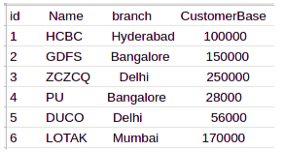

Note: Print the complete table after updating the data.

+----+-------+-----------+--------------+

| id | Name | branch | CustomerBase |

+----+-------+-----------+--------------+

| 1 | HCBC | Hyderabad | 100000 |

| 2 | GDFS | Noida | 150000 |

| 3 | ZCZCQ | Noida | 250000 |

| 4 | PU | Noida | 28000 |

| 5 | DUCO | Noida | 56000 |

| 6 | LOTAK | Mumbai | 170000 |

+----+-------+-----------+--------------+

Update Bank set branch = 'Noida' where branch in ('Delhi','Bangalore');

Select * from Bank;

**Delete:**

**SQL Query - 8**

**Send Feedback**

**Problem Statement:**  
Consider a table named products, formulate a query deleting the record where product_id = 596 or 700.  
  
**Information about the table:**  
Table **products :** 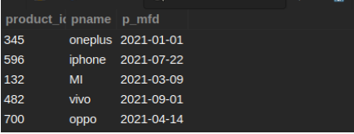

Note: Print the complete table after deleting the data.

Delete from products where product_id in (596,700);

Select * from products;

DELETE 2

product_id | pname | p_mfd

------------+----------------------------------------------------------------------------------------------------------------------------------------------------------------------------------------------------------+------------

345 | oneplus | 2021-01-01

132 | MI | 2021-03-09

482 | vivo | 2021-09-01

(3 rows)

**SQL Query - 9**

**Send Feedback**

**Problem Statement:**  
Someone has mistakenly added the wrong data in the table as the data only for people above Age 20 was needed. You have to remove the data of all such people whose age is less than equal to 20 years.  
  
**Information about the table:**  
Table **stud_data:**  


Note: Print the complete table after updating the data.

+---------+---------+------+

| roll_no | Fname | Age |

+---------+---------+------+

| 17 | Rishi | 23 |

| 7 | Shantnu | 21 |

| 50 | Lokesh | 23 |

+---------+---------+------+

Delete from stud_data where age <=20;

Select * from stud_data;

**SQL Query - 10**

**Send Feedback**

**Problem Statement :**  
It’s a time of recession so a new startup company has to cut down on its employee base to reduce its expenses and it has decided to remove all those employees whose name contains “an” in their name and have salary more than 100000, so update the database accordingly.  
  
**Information about the table**  
Table **Employee :** 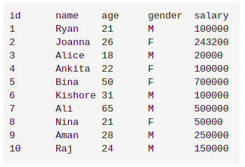

Note: Print the complete table after updating the data.

Delete from Employee where name like '%an%' and salary > 100000;

Select * from Employee;

+----+---------+-----+--------+--------+

| id | name | age | gender | salary |

+----+---------+-----+--------+--------+

| 1 | Ryan | 21 | M | 100000 |

| 3 | Alice | 18 | M | 20000 |

| 4 | Ankita | 22 | F | 100000 |

| 5 | Bina | 50 | F | 700000 |

| 6 | Kishore | 31 | M | 100000 |

| 7 | Ali | 65 | M | 500000 |

| 8 | Nina | 21 | F | 50000 |

| 10 | Raj | 24 | M | 150000 |

+----+---------+-----+--------+--------+

**REPLACE:**

**SQL Query - 11**

**Send Feedback**

**Problem Statement :**  
Data for id 103 has been incorrectly entered. As a school Data manager, you have to correct this data with the correct student name and admission data.  
  
Use the Replace command. **Name should be “Lawrence”** and **admission_date should be 2008-11-27.**  
  
**Information about the table**  
Table **Student :**  
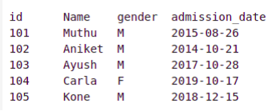

Note: After correcting the entry, print the updated Student table.

+-----+----------+--------+----------------+

| id | Name | gender | admission_date |

+-----+----------+--------+----------------+

| 103 | Lawrence | M | 2008-11-27 |

+-----+----------+--------+----------------+

Replace into Student (id,Name,gender,admission_date)

values(103,'Lawrence','M','2008-11-27');

Select * from Student;

**SQL Query - 12**

**Send Feedback**

**Problem Statement**  
Due to multiple issues due to the wrong data insertion of a person with id 305, the company needs to replace the data with its correct information. Formulate a query for the same.  
  
Correct Information is : 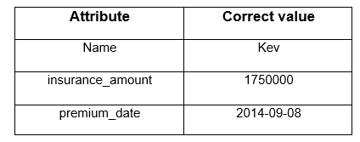  
  
**Information about the table**  
Table **Insurance :** 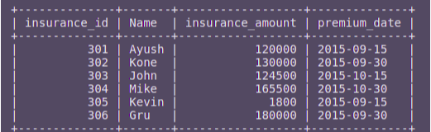

Note: Display the table after updating

+--------------+-------+------------------+--------------+

| insurance_id | Name | insurance_amount | premium_date |

+--------------+-------+------------------+--------------+

| 301 | Ayush | 120000 | 2015-09-15 |

| 302 | Kone | 130000 | 2015-09-30 |

| 303 | John | 124500 | 2015-10-15 |

| 304 | Mike | 165500 | 2015-10-30 |

| 305 | Kev | 1750000 | 2014-09-08 |

| 306 | Gru | 180000 | 2015-09-30 |

+--------------+-------+------------------+--------------+

Replace into Insurance set insurance_id = 305,Name = 'Kev',insurance_amount = 1750000,premium_date = '2014-09-08';

Select * from Insurance;

**SQL Query - 13**

**Send Feedback**

**Problem Statement**  
Given the table cities, form a query using REPLACE, to update/add the given data:  
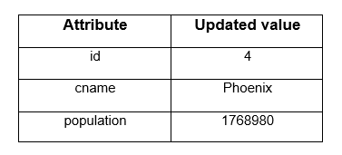  
  
**Information about the table**  
Table **cities :**  
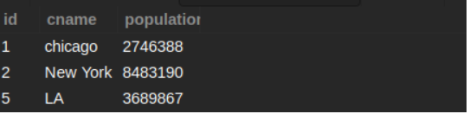

Note: Print the table afterwards.

+------+----------+------------+

| id | cname | population |

+------+----------+------------+

| 1 | chicago | 2746388 |

| 2 | New York | 8483190 |

| 5 | LA | 3689867 |

| 4 | Phoenix | 1768980 |

+------+----------+------------+

Replace into cities set id = 4,cname = 'Phoenix',population = 1768980;

Select * from cities;